**SQL QUERIES**

Q1)

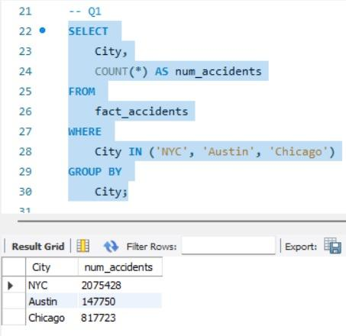

Q2)

Q3)

1. **OVERALL -**

1. **CITY WISE -**

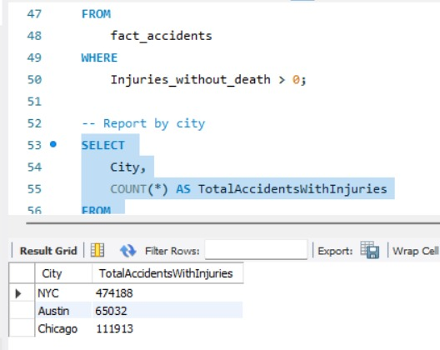

**Q4)**

**OVERALL**

**CITY WISE -**

**Q5)**

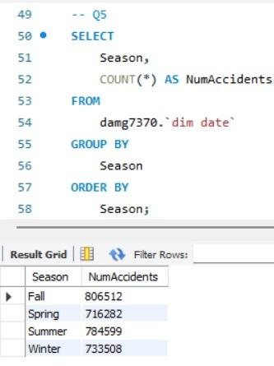

**Q6)**

**OVERALL -**

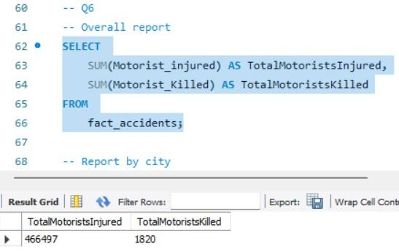

**CITY WISE -**

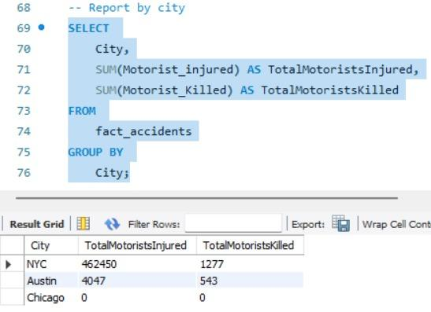

**Q8)**

**TIME OF DAY -**

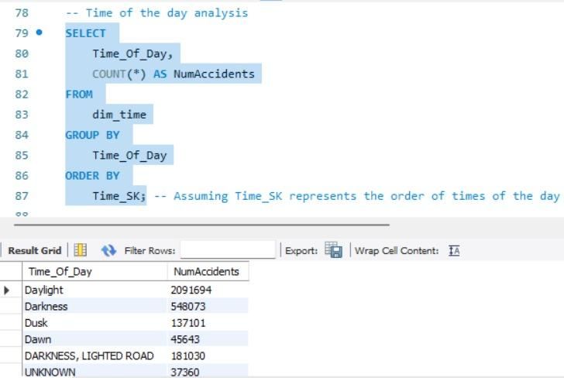

**DAY OF WEEK -**

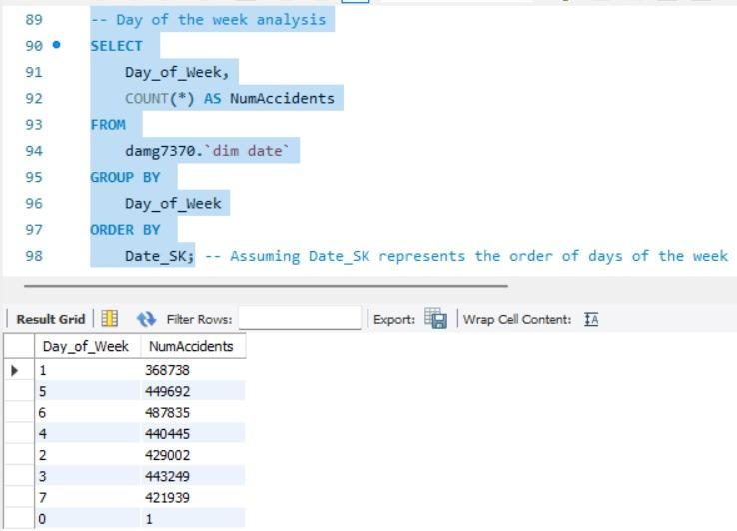

**WEEKDAYS AND WEEKENDS -**

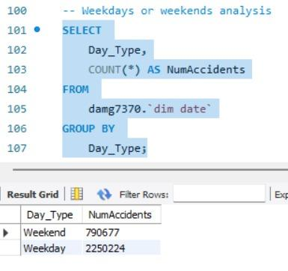

**Q9)**

